Computer Networks: Assignment #02
Wireshark Lab: HTTP

Name:Abdullah Ayub
Roll No: BSDSF24M029

Introduction
This assignment explores the HTTP protocol, specifically focusing on the basic GET/response interaction, message formats, conditional GETs, handling of large files, embedded objects, and basic authentication mechanisms using the Wireshark packet sniffer.

The Basic HTTP GET/response interaction
URL: http://gaia.cs.umass.edu/wireshark-labs/HTTP-wireshark-file1.html
  - Is your browser running HTTP version 1.0 or 1.1? What version of HTTP is the server running?
Answer: Both the browser and the server are running HTTP/1.1.
  - What languages (if any) does your browser indicate that it can accept to the server? Answer: The browser indicates en-GB, en-US;q=0.9, en;q=0.8.
  - What is the IP address of your computer? Of the gaia.cs.umass.edu server? Answer: My Computer IP is 192.168.1.5 and the Server IP is 128.119.245.12.
  - Status code returned from the server: 200 OK.
  - When was the HTML file last modified? Answer: Tue, 28 Oct 2025 05:59:01
Figure 1: Initial HTTP GET/Response for file1.html
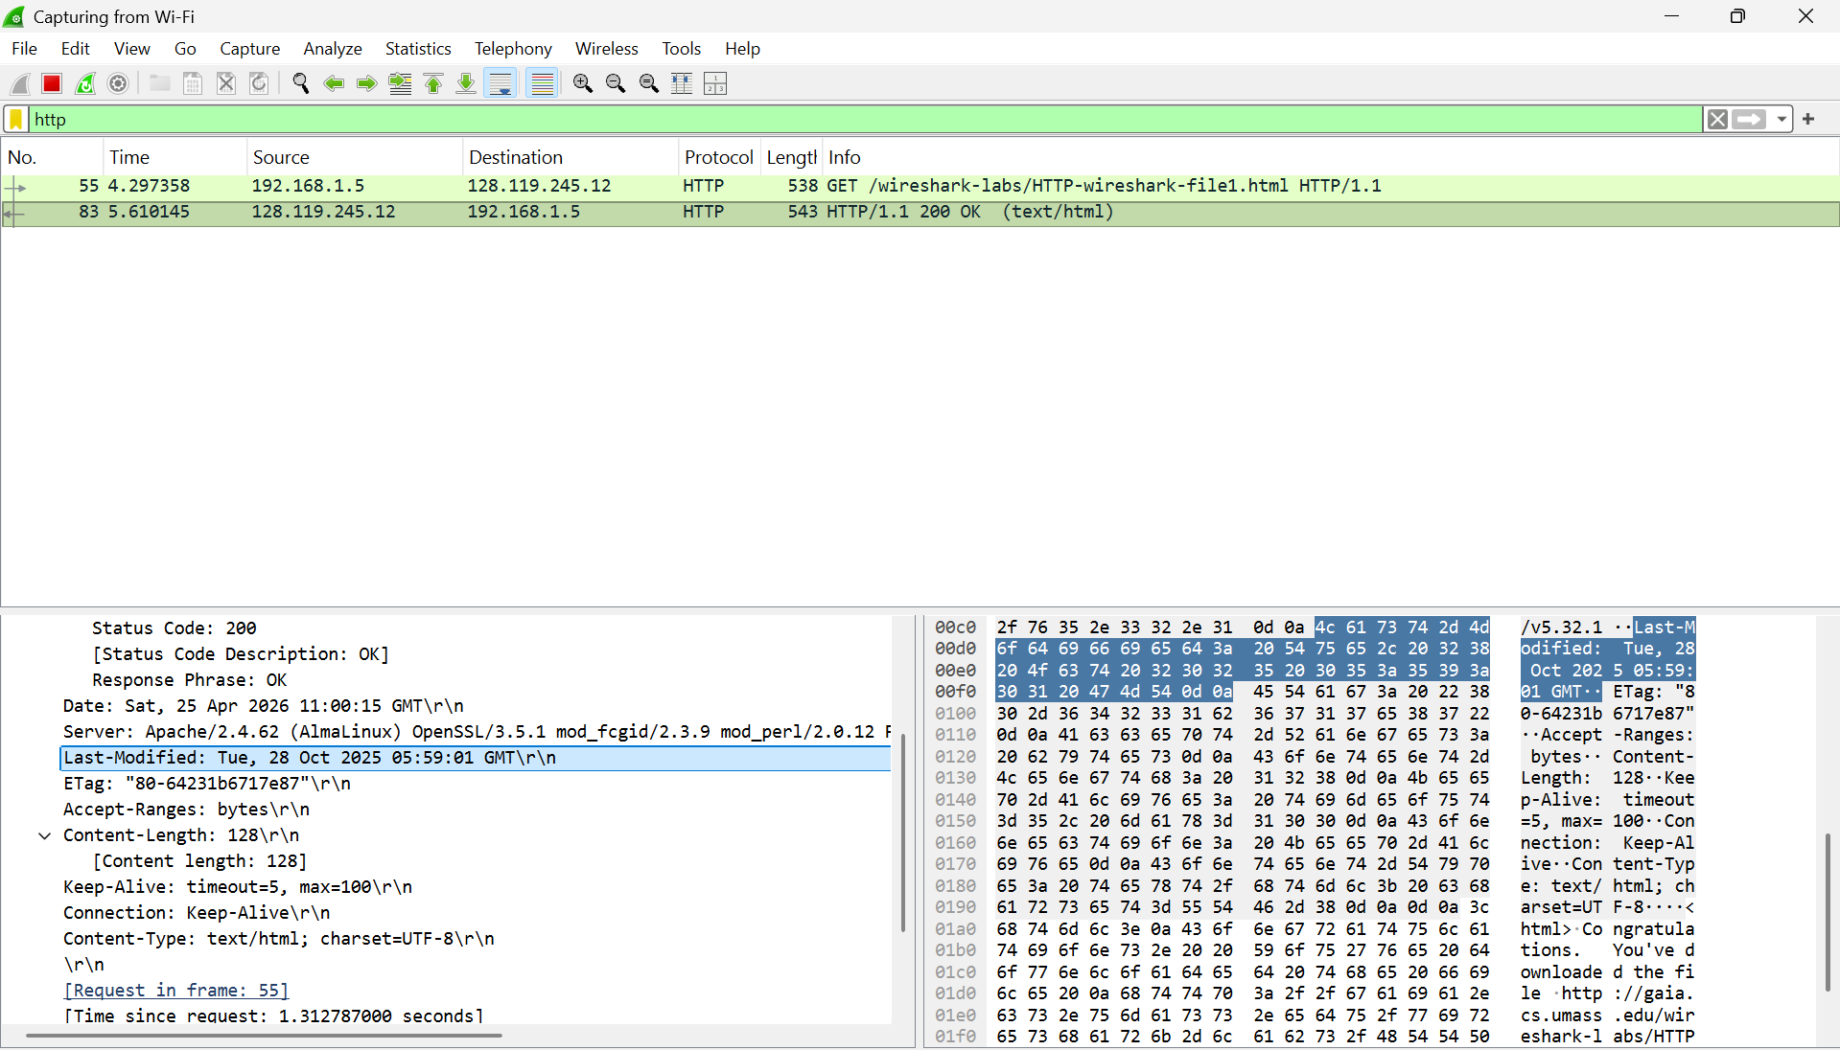

HTTP Conditional GET/response interaction
URL: http://gaia.cs.umass.edu/wireshark-labs/HTTP-wireshark-file2.html

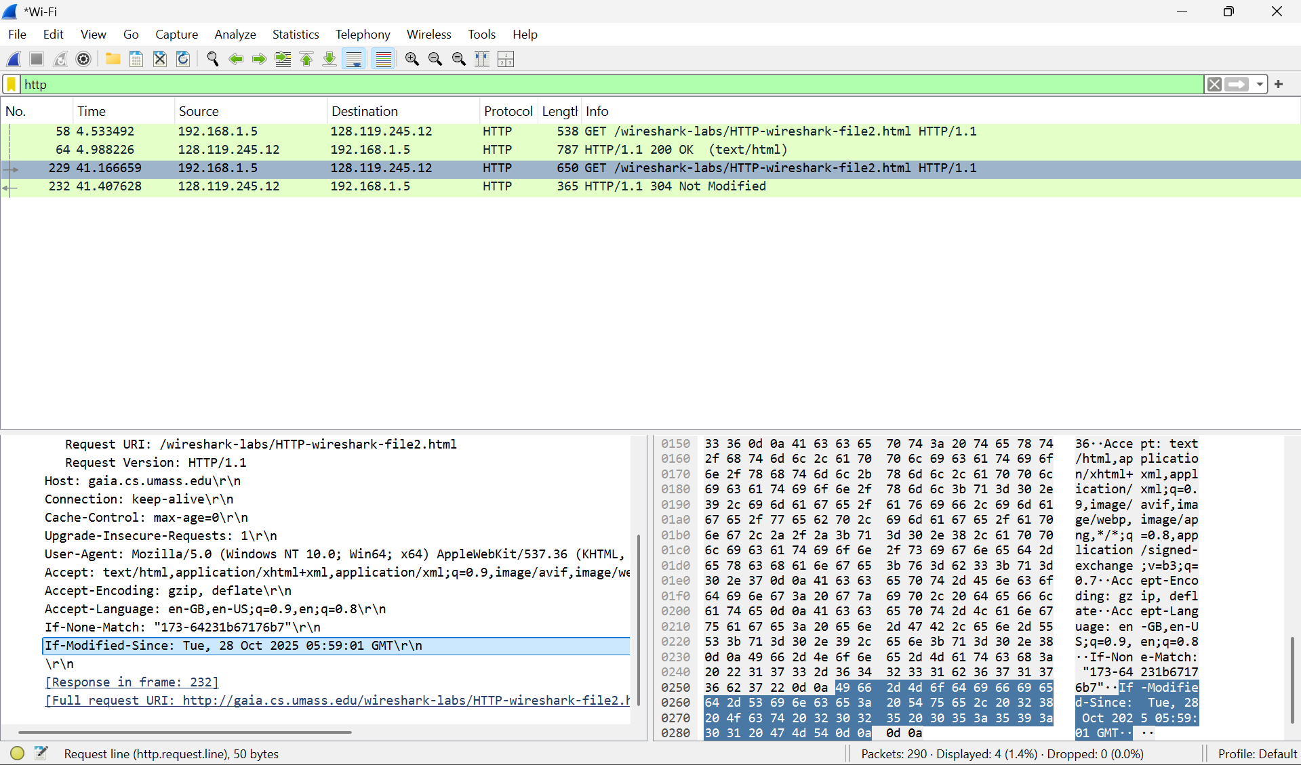
6. Does the second HTTP GET request contain an ”IF-MODIFIED-SINCE” line?
Answer: Yes. It is followed by: Tue, 28 Oct 2025 05:59:01 GMT.
7.What is the HTTP status code returned for the second GET? Answer: 304 Not Modified.

Retrieving Long Documents
URL: http://gaia.cs.umass.edu/wireshark-labs/HTTP-wireshark-file3.html
8.How many HTTP GET request messages did your browser send? Which packet num- ber in the trace contains the GET message for the Bill or Rights?
Answer: One GET request was sent. Packet number #3010.
9.Which packet number in the trace contains the status code and phrase associated with the response to the HTTP GET request?
Answer: Packet number #3035.
10.What is the status code and phrase in the response? Answer: 200 OK.
11.How many data-containing TCP segments were needed to carry the single HTTP re- sponse and the text of the Bill of Rights?
Answer: 2 TCP segments were used to carry the response.

HTML Documents with Embedded Objects
URL: http://gaia.cs.umass.edu/wireshark-labs/HTTP-wireshark-file4.html
12.How many HTTP GET request messages did your browser send? To which Internet addresses were these GET requests sent?
Answer: Three GET requests were sent. All were sent to 128.119.245.12.
13.Can you tell whether your browser downloaded the two images serially, or whether they were downloaded from the two web sites in parallel? Explain.
Answer: They were downloaded serially because the second GET request was only sent
after the first image’s TCP connection was active.

HTTP Authentication
URL: http://gaia.cs.umass.edu/wireshark-labs/protected_pages/HTTP-wireshark-file5.html
14.What is the server’s response (status code and phrase) in response to the initial HTTP GET message from your browser?
Answer: 401 Unauthorized.
15.When your browser sends the HTTP GET message for the second time, what new field is included in the HTTP GET message?
Answer: The Authorization: Basic field is now included.

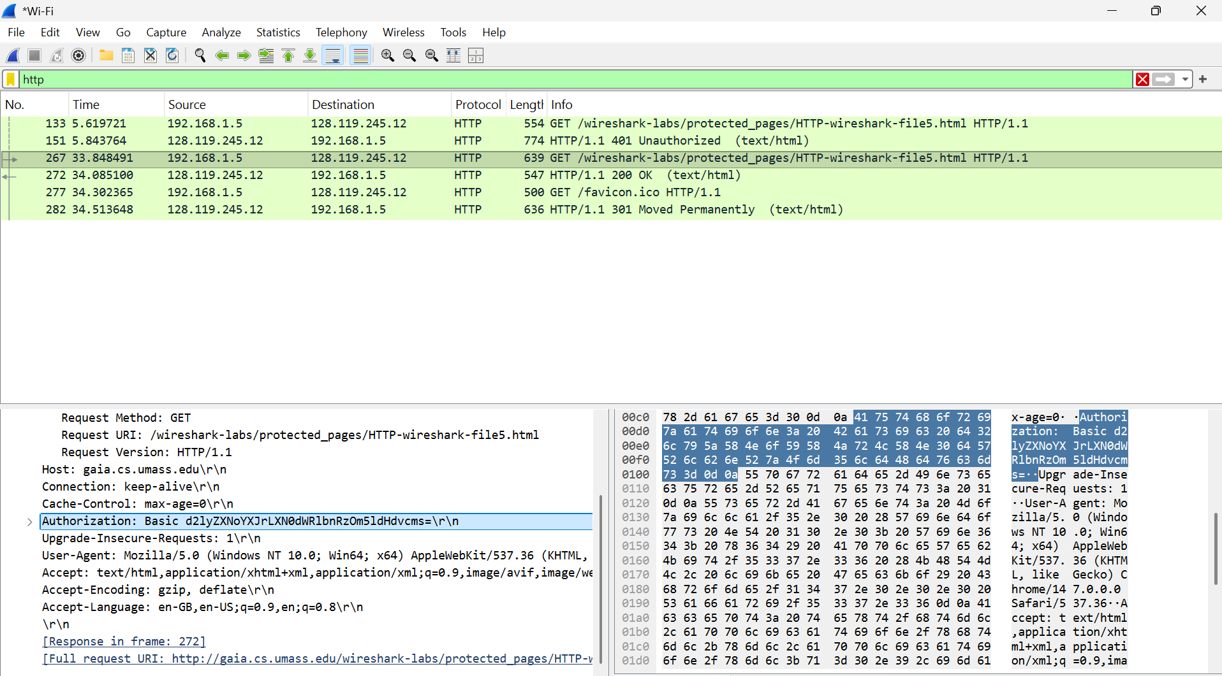
16.What is the username and password that you entered? Answer: Username: wireshark-students, Password: network.

17.What is the ”Credentials” string in the Authorization header? Answer: The string is d2lyZXNoYXJrLXN0dWRlbnRzOm5ldHdvcms=.
18.What is the status code and phrase returned by the server in response to the second HTTP GET?
Answer: 200 OK.
19.Explain how the browser sends the password to the server. Is it secure?
Answer: The browser sends the credentials in the Authorization header using Base64 encoding. This is not secure because encoding is easily reversible and does not provide encryption.

